Lab 1 Frontend Setup

1. Download Visual Studio Code: https://code.visualstudio.com/download
2. Install nvm (node version manager)
- Instructions for mac:
Install homebrew: https://brew.sh
/bin/bash -c "$(curl -fsSL https://raw.githubusercontent.com/Homebrew/install/HEAD/install.sh)"
Install nvm using brew:
brew install nvm
Source nvm in your shell profile: Open your terminal and type
nano ~/.zshrc
Add the following to your shell profile and exit by pressing ctrl + X and Y to save the changes
export NVM_DIR="$HOME/.nvm"
[ -s "$(brew --prefix nvm)/nvm.sh" ] && \. "$(brew --prefix nvm)/nvm.sh"
[ -s "$(brew --prefix nvm)/etc/bash_completion.d/nvm" ] && \. "$(brew --prefix nvm)/etc/bash_completion.d/nvm"
- Verify Installation:

nvm --version

3. Install node using nvm
- Instructions for mac:
Install node using nvm: To view the latest node versions available
nvm ls-remote
Install the latest version of node
nvm install node
OR
Install a specific version of node
nvm install 25.2.1
- Verify Installation:
To list all the installed versions
nvm ls
If multiple versions of node are installed, you can set a specific version as default
nvm use 25.2.1

For users with operating system other than mac, please follow the instructions on following link to install nvm and node
https://www.nvmnode.com/guide/download.html

4. Setup Github/Gitlab:
- Create a new repository in your GitHub/GitLab
- Install Git on your system: https://git-scm.com/install/linux
- Instructions for mac:
Installation via homebrew:
brew install git

- Create new Project: Create an empty project in your GitLab/GitHub and copy the https path
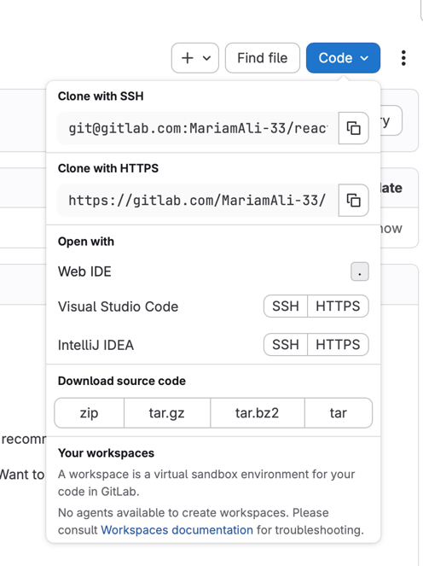

Open the folder where you want to create the new project, open a terminal in that directory, and run the following command to clone the repository to your local machine
git clone <https_path>
To set up your identity for a specific project, run the following commands inside the project directory. If you want to apply the configuration to all repositories on your system, add the --global flag. However, it is considered best practice to configure your identity individually for each project.
git config user.name "your github username"
git config user.email "your github email"
To view your configurations
git config --list

Create a new branch named “develop” and switch to it using the following command
git checkout -b develop
- Verify:
Run the following command to list all the branches and verify which branch you are currently in
git branch

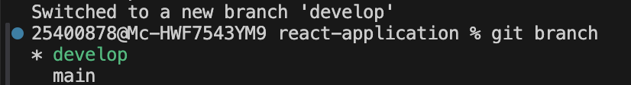
5. Install REACT:
Install build tool Vite using npm
npm install -g create-vite
Create a new React application using Vite by replacing “app-name” with your desired project name, then run the following command:
npm create vite@latest app-name -- --template react

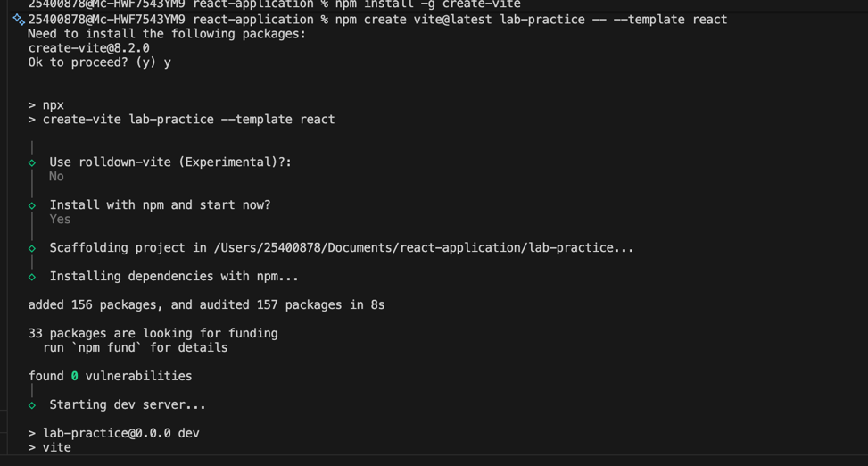
- Verify:
Visit http://localhost:5173/ to view your REACT application
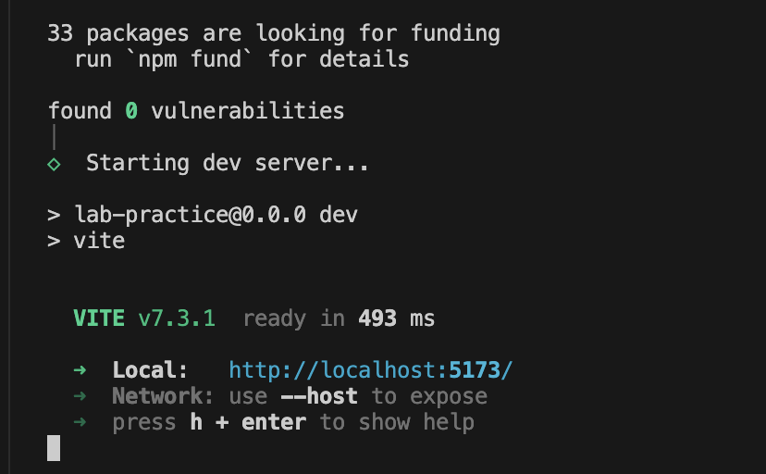

Navigate to the app-name/src/App.jsx file to make your initial changes, as this is the main entry component of your application. Any updates made to this file will be reflected in real time in the browser during development. To ensure changes are saved automatically, go to File → Auto Save and enable it

6. Install Extensions: To enhance your development experience, please install the following VS Code extensions. Go to the Extensions panel in VS Code, search for each extension by name, and click Install. Be sure to read the description of each extension to understand its purpose. These tools will support and improve your web development workflow in future labs.
- ES7 React/Redux/GraphQL/React-Native snippets,
- Prettier,
- npm IntelliSense,
- Simple React Snippets,
- ESLint,
- GitLens,
- Auto Rename tag,
- Colorize
7. Push to GitHub/Gitlab:
- After making changes to your React project, you can upload it to GitHub/Gitlab
git add .
git commit -m “pushing react application”
git push origin develop

8. Additional Resources:
https://react.dev/learn/build-a-react-app-from-scratch
https://www.w3schools.com/react/react_getstarted.asp

